**18.3.1**

We were here at 8 in the morning, now It’s 2 o’clock in the afternoon

How many good idea do we have?

One or two

This is hard!

Really the take a break

Yes, my head hurt

Ok, we can take a break

What do you want to do?

I want to go to the bathroom first

Can we go out?

Yes, please. We need to leave my apartment to help a thinks

Yes.

What are we doing?

We’re leaving the apartment

Where we go?

We don’t know

Do you want to go to the movies? I want to see the new Dan Blaze’s movie

Yes, but we don’t have time to go to the movie

We can go to the part

And what?

We can play foodball

I’m good at football

I’m bad at football

No. Football

Do you want to go cycling?

I have one bicycle not free

OK. No cycling

Do you want to play tennis?

I play tennis

I don’t play tennis

No play tennis

We can do exercises?

Do exercises? That’s not fun. Why don’t we do homework?

OK. Do you want to go for a run, to go see a movie?

That was my idea

OK, it’s a good idea

Let’s go!

It’s raining

What do Marco , Khae and Aanya talk about?

* Things to do

Why do Marco, Khae , and Aanya want to take a break?

* Their work is difficult.

Khae thinks they need to go outside to help them think.

Why can’t they go cycling?

* Only Khae has a bike.

Marco thinks exercises are boring.

**Skill Practice**

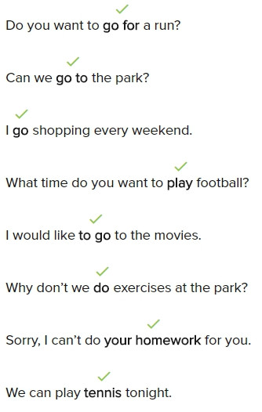

**Conversation**

I’m so happy It’s Friday. what do you want to do tomorrow?

I want to have fun.

Do you want to play tennis?

I can’t play tennis. Do you want to play basketball?

I’m not good at basketball. We can you exercises?

No, Exercise is not fun. Why don’t we go cycling?

I don’t have a bike. But we go running in the park.

I can’t because I don’t have any running shoes.

Do you want to go shopping to buy some?

I love shopping , but I don’t have much money.

Then, let’s watch a movie.

Good idea! We can go to the movies.

**Exercise**

I want to **play** basketball tomorrow

I can’t go out tonight; I have to do my homework

Do you want to stay home and cook tonight?

* Yes, but we don’t have any food. We need to go to the supermartket

I go swimming every day after school

I can’t do math. It is too difficult

I want to be healthy.

* You have to do exercise.

My homework is very difficult. Can you help?

* I can help you, but I can’t do it for you.

Are you good at tennis?

* Yes, I play with my roommate every Sunday.

The new movie with Dan Blaze starts tomorrow.

Great! Do you want to watch it next weekend?

This is boring. Do you want to go to the movies?

Good idea. I want to see an exciting movie.

**18.3.2**

You go swimming? Hmm, you don’t look like you go swimming

Yes, I go swimming

**When do you go swimming?**

**I go swimming everyday, in the afternoon**

Everyday?

Yes, I go swimming every day

**Where do you go swimming?**

**There’s a pool at the gym.** **I go swimming in the pool there**

Why do you like swimming?

I like to be in the water

I like to go swimming in the ocean

Where is your swimsuit?

It’s in my bag

Don’t look in my bag

What do Marco, Khae, and Aanya talk about?

* Swimming

When does Marco go swimming?

* Every afternoon

Where does Marco go swimming?

* At the gym

Why does Marco like swimming?

* He likes the water

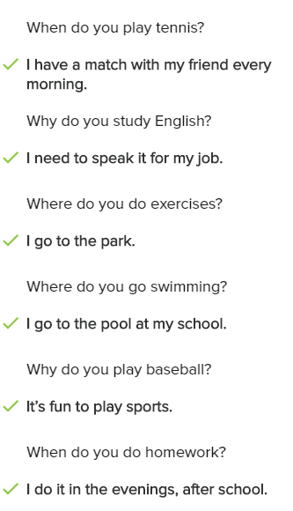

When does Marco swim?

* In the afternoon

Where does Marco swim?

* At the gym

What does Marco like about swimming?

* He likes the water

**Conversation**

What do you like to do when you aren’t working?

I like to like sports

What sports do you like to play?

I like to play tennis and basketball

I know you also play tennis, when do you play?

I play every weekend on Saturday and Sunday

Where do you go to play?

I go to the park to play tennis

Who do you go with?

I go with my girlfriend

Why do you like sports?

I play sports because they are fun, and I can get healthy

Do you like to watch sports too?

Yes, I love to watch sports on TV

What does the woman like to to when she has time?

➔ Play tennnis

When does the nam listen to music?

➔ In the morning

Why deos the man like going to the part?

➔ He likes to be outside

What is the woman’s hobby?

➔ Playing sports

Where does the man like to read?

➔ At home

Why does the woman like movies?

➔ She thinks movies are exciting

Where does the man go swimming?

➔ At his univerity

When does the man cook?

➔ On Saturdays and Sundays

18.3.3

Can we watch something?

Yes, we can. **Do you want to watch a movie or a TV show**

**I like TV shows but Marco likes movies**

That’s not true, **I like good TV shows, but not bad TV shows**

No one like bad Tv show, Marco

Can we watch a movie?

OK. I can find the short movies, I don’t like long movies

**I love long movies, but you don’t**

We don’t have time for a long movie

What watch this movie...do you want popcorn?

Yes, with butter _

What with sauce not butter

**She wants butter, but you don’t**

Yep!

OK, do you want something to drink?

I want a coffee

I want a tea

**I’m good at makeing tea, but bad at making coffee**. Do you want tea?

No, **I like coffee but I don’t like tea**. I can make a coffee

Thank Macro! You and Aanya don’t like the same things

That’s not true, we like you

That’s right

Oh, then you can make popcorn for me. I like it with no butter and no sauce

What do Marco, Khae, and Aanya choose to do?

* Watch a movie

Why do they want to watch a short movie?

* They don’t have a lot of time

Marco ans Khae don’t want the same things

Who goes to make the popcorn and drinks?

* Marco and Aanya

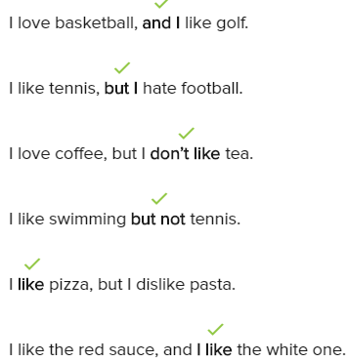

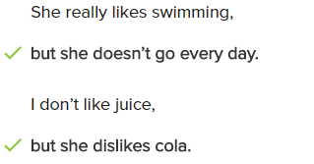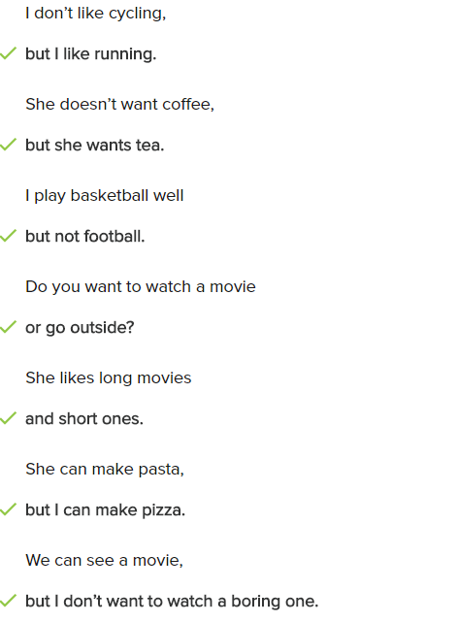

**Conversation**

Do you have any brother or sister?

I have one brother, but I don’t have any sister

Do you see your brother a lot?

Yes, we play sport together every weekend

Do you and your brother play the same sport?

No, I like tennis, but he likes basketball

Are you good at tennis?

Yes, I’m good at it, but I’m bad at basketball

Is your brother good at tennis?

No, he’s not good at tennis, but he good at basketball

Do you have any hobby?

Yes, I like watching movie and listenning to music

Do you like long movies?

I like short movie but not long one

Would you like to watch to movie now?

I’m busy so I can’t watch a movie now, but I can watch one next weekend

**Exercise**

I want sugar in my coffee, but I don’t want milk

My computer is small and it is fast.

I like apples , but I don’t like oranges.

I study English because I want to speak well.

I’m good at English , but I am bad at math.

I like pasta but not pizza.

I want to eat chicken , and I want to eat beef.

I can sing, but I hate dancing.

I know how to drive a car , but I don’t have one.

This computer is great, but it’s expensive.

**Lesson Exercise**

We can do exercies!

I like coffee, but I don’t like tea

My neighbor likes to go shopping

Do you like to play football or basketball

Lana hates to do her math homework!

Can you go cycling in the part with me on Saturday?

I only do exercies at home in my apartment

Does your sister play music on her laptop?

It’s a sunny day. Let’s go to the beach

* Ok, I’d like to go swimming in the ocean

Do you want to come to teh gym with me?

* No, I do exercies today. I’m very tired

I don’t have to work today. What do you want to do?

* I’m working on a new jazz song. Let’s play some music together

Can you go shopping with me at the market?

* Sorry, I can. I have to do a lot of homework

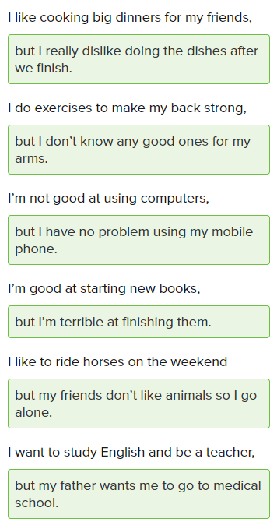

Do you ride the bus to work or do you take the subway?

* I hate riding the bus and taking the subway, but I love riding my bicycle to work.

Are you full? Can you eat some more?

* I’m not hungry , but I’m thirsty and want something to drink.

Do you use a lot of salt and butter in your cooking?

* I don’t use a lot of salt , but I use a lot of butter.

Where do you want to go?

* Somewhere fun, but not very loud. I have a headache.

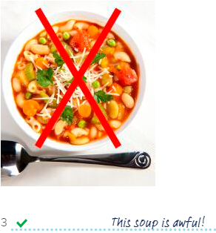

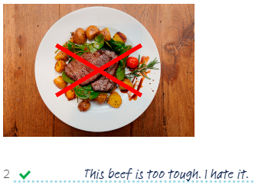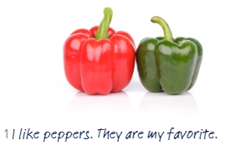**Book**

**1/1**

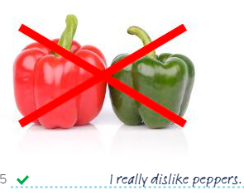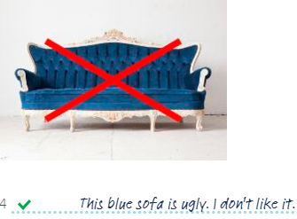

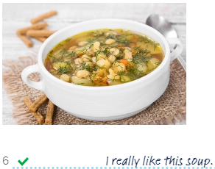

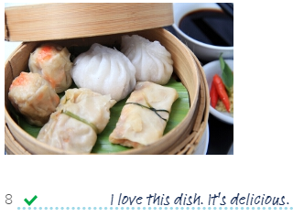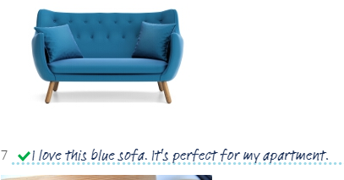

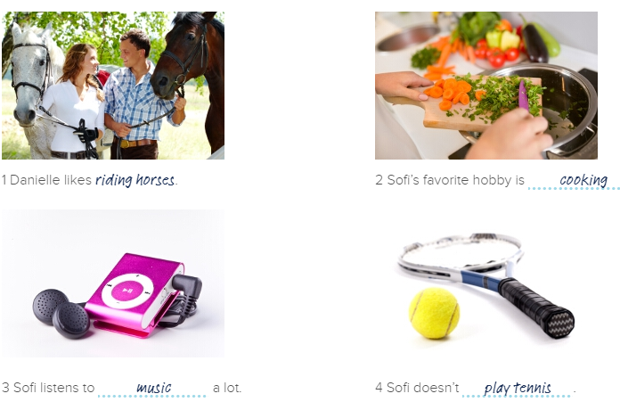**2/8**

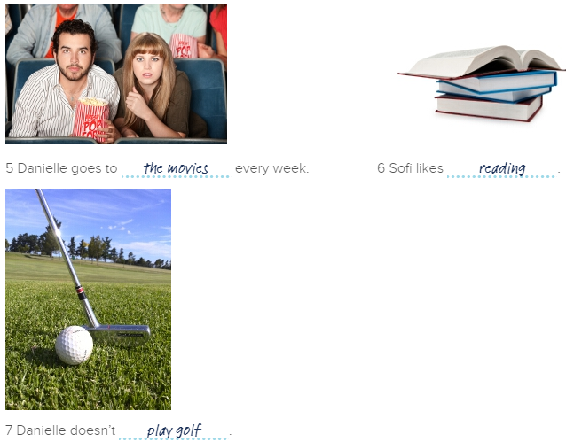

**3/8**

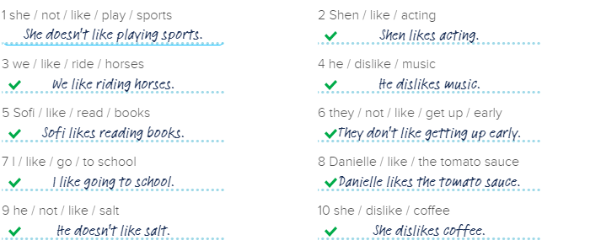

**4/8**

1 Do you like pizza?

Yes, I like pizza.

2 Do you like playing sports?

No, I don't like playing sports.

3 Does she like music?

Yes, she likes music. She loves jazz.

4 Do they like going to the movies?

No, they don't like going to the movies.

They think movies are boring.

5 Does she like riding horses?

Yes, she likes riding horses.

6 Do you like going to work early?

No, I don't like going to work early.

7 Do you like the soup?

No, I dislike the soup. It tastes terrible.

8 Does she like reading books?

Yes, she likes reading books. She reads a lot.

9 Do you like sleeping late?

No, I dislike sleeping late. I wake up early every morning.

10 Do they like playing golf?

Yes, they like playing golf. They play golf every weekend.

**5/8**

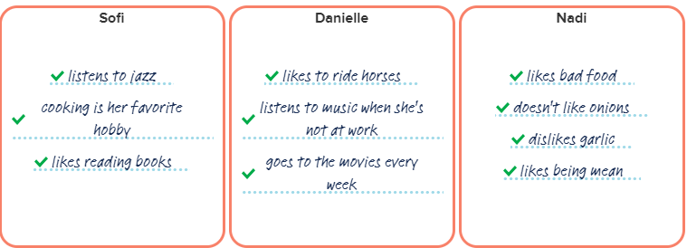

**6/8**

Nadi: We need a new dish for our menu.

Sofi: I have a new dish. It's my new recipe.

Nadi: What's in it?

Sofi: There is tomato sauce, beef, cheese, and cream.

Nadi: I hate tomatoes! And the beef...

Sofi: Do you like the beef?

Nadi: The beef is too tough, and it has a lot of salt.

Sofi: Do you like the salt in the dish?

Nadi: Yes. I like a lot of salt.

Sofi: So you like salt. And do you like the white sauce?

Nadi: The white sauce is not great. What's in the white sauce?

Sofi: There is garlic in the white sauce.

Nadi: Ah! I dislike garlic!

Sofi: So, do you like the dish?

Nadi: I hate the dish. Make a new dish, but no tomatoes and garlic!

**7/8**

Sofi likes cooking. It is her favorite hobby. Today Nadi needs a new dish for the menu. She wants Sofi to cook a new dish. Sofi is happy to cook a new dish. She has a new recipe. It has chicken, onions, peppers, garlic, cream, and pasta. Danielle tastes the dish. She loves it! Danielle thinks the new dish is delicious. Nadi tastes the dish. She hates it! Nadi dislikes onions, peppers, and garlic. She thinks the dish tastes weird. Nadi is not happy. Danielle and Sofi don’t like Nadi. They think she is mean and hates good food.

1 What is Sofi’s favorite hobby?

Cooking is her favorite hobby.

2 What does Nadi need?

Nadi needs a new dish for the menu.

3 What does Sofi cook?

She cooks a new recipe.

4 What does the new dish have?

The new dish has chicken, onions, peppers,garlic, cream, and pasta.

5 What does Danielle think about the new dish?

Danielle thinks the dish is delicious. She loves it.

6 What does Nadi think about the new dish?

Nadi hates the new dish. She thinks it tastes weird.

7 What do Danielle and Sofi think about Nadi?

They think Nadi is mean and hates good food.

8/8

I have a lot of hobbies. My favorite hobby is dancing. I take dance lessons every Friday. I also love listening to music. I listen to music when I’m at work and in my car. I also like watching TV in my free time. I like watching movies and TV shows. I like readings books and going out with my friends.  
  
My favorite sport is tennis. I play it almost every day with my friend. I also like watching football, but I hate golf and cricket. I think these sports are boring.  
  
There are things I hate doing. I hate cleaning my apartment. I also dislike shopping. My favorite food is pizza and pasta, but I really hate chicken and beef.